

# PROJECT: BookStore GROUP NO: 03

# SYSTEM REQUIREMENTS:

1. **Hardware**:

**Web Server**

* Processor Intel Core I3 or higher.
* Memory 6 GB RAM or greater.
* Modem/ADSL Internet access is required.

**Client**

* Processor Intel Core I3 or higher.
* Memory 6 GB RAM or greater.
* Monitor Super VGA (1024x768) or higher resolution.
* Modem/ADSL Internet access is required.

1. **Software**:

**Server:**

* Web server: Apache Netbeans IDE 19
* Operation System: Window 7 or later.
* Databases: MySQL.

**Client:**

* Operation System Window 7 or higher.

# Program Instrallation

1. **DOWNLOAD FILES FROM GITHUB**

Step 1. Download file from github : [GitHub - NAonlines/Book-Store_Group3](https://github.com/NAonlines/Book-Store_Group3)

Step 2. Extract Book-Store_Group3-NAonlines-Eproject.zip file in this folder.

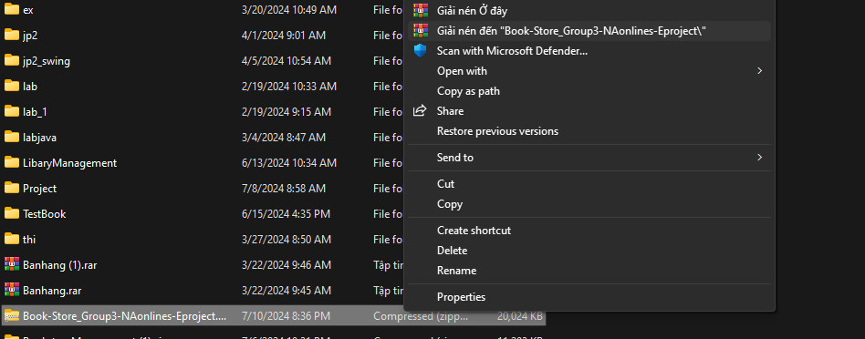

Step 3 . Open netbeans and add the extracted file into netbeans

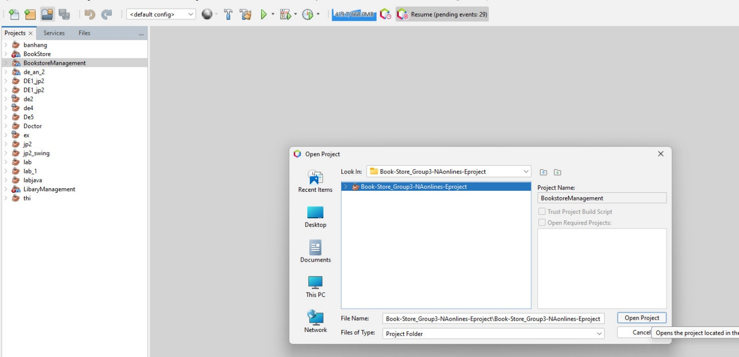

Step 3. Open the BookstoreManagement folder and continue to select BookstoreManagement then continue to double-click on BookstoreManagement.java and right-click and select run

# C. Successful test

- The file is loaded successfully

- Homepage should be displayed as described in the documentation.

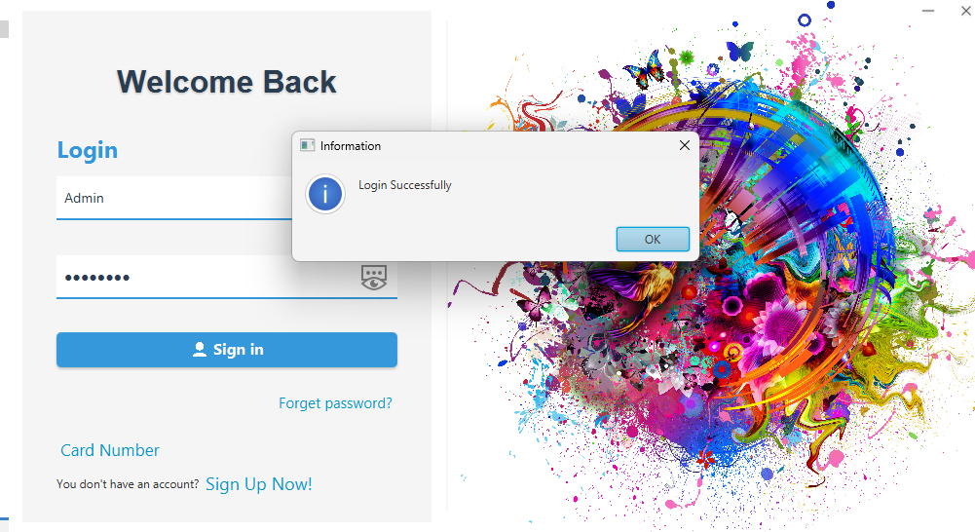

* Additional

Login account, use one of the following accounts:

|  |  |
| --- | --- |
| **Username** | **Password** |
| admin | Admin123 |
| User | User123 |
|  |  |